**Creating Get-WinEvent queries with FilterHashtable**

To read the original June 3, 2014 Scripting Guy blog post, see Use FilterHashTable to Filter Event Log with PowerShell

This article is an excerpt of the original blog post and explains how to use the GetWinEvent cmdlet's FilterHashtable parameter to filter event logs. PowerShell's Get-WinEvent cmdlet is a powerful method to filter Windows event and diagnostic logs. Performance improves when a GetWinEvent query uses the FilterHashtable parameter.

When you work with large event logs, it's not efficient to send objects down the pipeline to a WhereObject command. Prior to PowerShell 6, the Get-EventLog cmdlet was another option to get log data. For example, the following commands are inefficient to filter the Microsoft-Windows-Defrag logs:

**PowerShellCopy**

Get-EventLog -LogName Application | Where-Object Source -Match defrag

Get-WinEvent -LogName Application | Where-Object { $_.ProviderName -Match 'defrag' }

The following command uses a hash table that improves the performance:

PowerShellCopy

Get-WinEvent -FilterHashtable @{

LogName='Application'

ProviderName='*defrag'

}

Blog posts about enumeration

This article presents information about how to use enumerated values in a hash table. For more

information about enumeration, read these Scripting Guy blog posts. To create a function that returns

the enumerated values, see Enumerations and Values. For more information, see the Scripting Guy series

of blog posts about enumeration.

Hash table key-value pairs

To build efficient queries, use the Get-WinEvent cmdlet with

the FilterHashtable parameter. FilterHashtable accepts a hash table as a filter to get specific information

from Windows event logs. A hash table uses key-value pairs. For more information about hash tables,

see about_Hash_Tables.

If the key-value pairs are on the same line, they must be separated by a semicolon. If each key-value pair

is on a separate line, the semicolon isn't needed. For example, this article places key-value pairs on

separate lines and doesn't use semicolons.

This sample uses several of the FilterHashtable parameter's key-value pairs. The completed query

includes LogName, ProviderName, Keywords, ID, and Level.

The accepted key-value pairs are shown in the following table and are included in the documentation for

the Get-WinEvent FilterHashtable parameter.

The following table displays the key names, data types, and whether wildcard characters are accepted for

a data value.

Key name Value data type Accepts wildcard characters?

LogName <String[]> Yes

ProviderName <String[]> Yes

Path <String[]> No

Keywords <Long[]> No

ID <Int32[]> No

Level <Int32[]> No

StartTime <DateTime> No

EndTime <DateTime> No

UserID <SID> No

Data <String[]> No

<named-data> <String[]> No

The <named-data> key represents a named event data field. For example, the Perflib event 1008 can contain

the following event data:

XMLCopy

<EventData>

<Data Name="Service">BITS</Data>

<Data Name="Library">C:\Windows\System32\bitsperf.dll</Data>

<Data Name="Win32Error">2</Data>

</EventData>

You can query for these events using the following command:

PowerShellCopy

Get-WinEvent -FilterHashtable @{LogName='Application'; 'Service'='Bits'}

Note

The ability to query for <named-data> was added in PowerShell 6.

Building a query with a hash table

To verify results and troubleshoot problems, it helps to build the hash table one key-value pair at a time.

The query gets data from the Application log. The hash table is equivalent to Get-WinEvent -LogName

Application.

To begin, create the Get-WinEvent query. Use the FilterHashtable parameter's key-value pair with the

key, LogName, and the value, Application.

PowerShellCopy

Get-WinEvent -FilterHashtable @{

LogName='Application'

}

Output :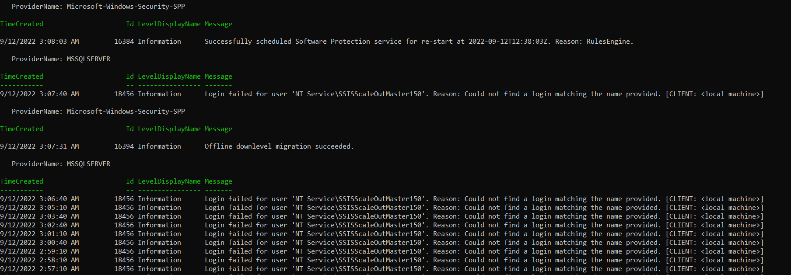

PowerShellCopy

Get-WinEvent -FilterHashtable @{

LogName='Application'

ProviderName='.NET Runtime'

}

Note

For some event providers, the correct ProviderName can be obtained by looking on the Details tab

in Event Properties. For example, events where the Source field shows Defrag, the

correct ProviderName is Microsoft-Windows-Defrag.

If your query needs to get data from archived event logs, use the Path key. The Path value specifies the

full path to the log file. For more information, see the Scripting Guy blog post, Use PowerShell to Parse

Saved Event Logs for Errors.

Using enumerated values in a hash table

Keywords is the next key in the hash table. The Keywords data type is an array of the [long] value type

that holds a large number. Use the following command to find the maximum value of [long]:

PowerShellCopy

[long]::MaxValue

Use the following command to display the StandardEventKeywords property names.

PowerShellCopy

[System.Diagnostics.Eventing.Reader.StandardEventKeywords] | Get-Member -Static -

MemberType Property

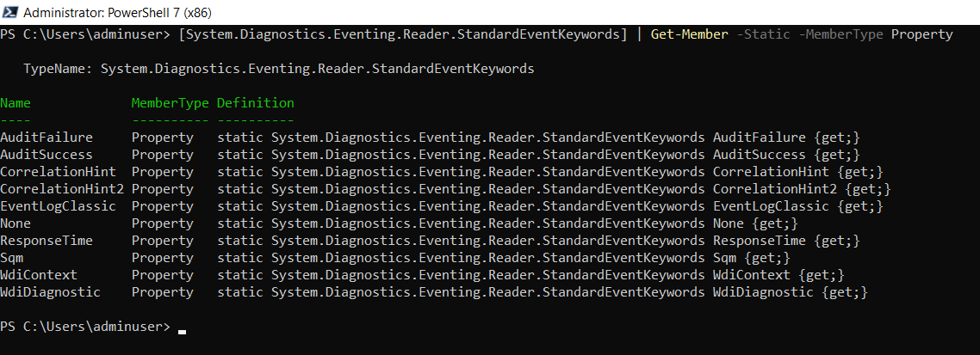

Update the hash table and include the key-value pair with the key, Keywords, and

the EventLogClassic enumeration value, 36028797018963968.

PowerShellCopy

Get-WinEvent -FilterHashtable @{

LogName='Application'

ProviderName='.NET Runtime'

Keywords=36028797018963968

}

Keywords static property value (optional)

The Keywords key is enumerated, but you can use a static property name in the hash table query. Rather

than using the returned string, the property name must be converted to a value with

the Value__ property.

For example, the following script uses the Value__ property.

PowerShellCopy

$C = [System.Diagnostics.Eventing.Reader.StandardEventKeywords]::EventLogClassic

Get-WinEvent -FilterHashtable @{

LogName='Application'

ProviderName='.NET Runtime'

Keywords=$C.Value__

}

Filtering by Event Id

To get more specific data, the query's results are filtered by Event Id. The Event Id is referenced in the

hash table as the key ID and the value is a specific Event Id. The Windows Event Viewer displays

the Event Id. This example uses Event Id 1023.

Update the hash table and include the key-value pair with the key, ID and the value, 1023.

PowerShellCopy

Get-WinEvent -FilterHashtable @{

LogName='Application'

ProviderName='.NET Runtime'

Keywords=36028797018963968

ID=1023

}

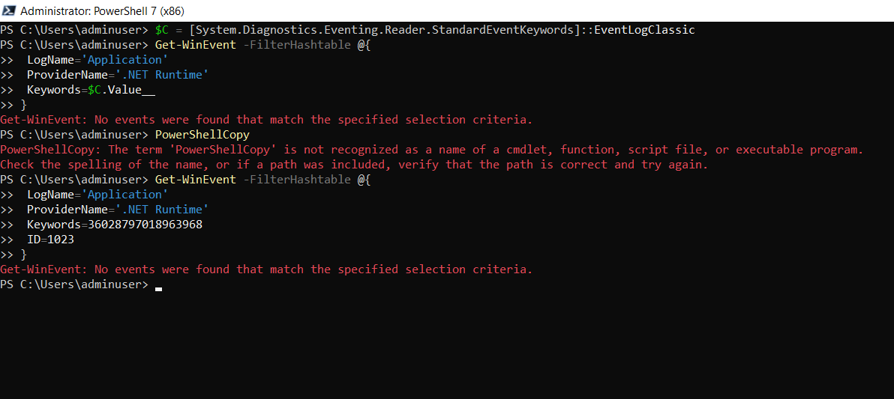

Filtering by Level

To further refine the results and include only events that are errors, use the Level key. Windows Event

Viewer displays the Level as string values, but they are enumerated values. In the hash table, if you use

the Level key with a string value, an error message is displayed.

Level has values such as Error, Warning, or Informational. Use the following command to display

the StandardEventLevel property names.

PowerShellCopy

[System.Diagnostics.Eventing.Reader.StandardEventLevel] | Get-Member -Static -

MemberType Property

PowerShellCopy

Get-WinEvent -FilterHashtable @{

LogName='Application'

ProviderName='.NET Runtime'

Keywords=36028797018963968

ID=1023

Level=2

}

Level static property in enumeration (optional)

The Level key is enumerated, but you can use a static property name in the hash table query. Rather than

using the returned string, the property name must be converted to a value with the Value__ property.

For example, the following script uses the Value__ property.

PowerShellCopy

$C = [System.Diagnostics.Eventing.Reader.StandardEventLevel]::Informational

Get-WinEvent -FilterHashtable @{

LogName='Application'

ProviderName='.NET Runtime'

Keywords=36028797018963968

ID=1023

Level=$C.Value__

}

